EE692 R&D Project

Ashrut Ambastha 03307913

Guide: Prof. Dinesh Sharma

Table of Contents

- Introduction

- The LH79520 ARM7TDMI System on Chip

- Memory Subsystem

3.1 The Boot ROM and Static Memory Controller (SMC)
3.2 System RAM and the Dynamic Memory Controller (SDRC)

- Display Controller and TFT Panel

5.0 Design Issues

Appendix A : Schematic Diagram
Appendix B: Top and Bottom Layer PCB Track Layout

References

1.0 Introduction

This project deals with the design and implementation of an ARM based single board computer for handheld medical monitoring applications. Although specifically intended for electrocardiogram data analysis and viewing, the design is kept general allowing usage of the system in a variety of embedded applications requiring low power consumption and high resolution display unit. The core processor is chosen such that it contains host of in-built peripherals which eases the overall design and gives the final system seamless compatibility with existing hardware and devices available.

Based around Sharp Microelectronics’ LH79520 Bluestreak processor, which is an ARM7TDMI core based system on chip (SoC), the board offers reasonable processing capability in the range of 38 BogoMIPS. The single board computer includes 4Mbytes of non-volatile memory that is used as boot ROM as well as OS code memory. 8MBytes of high-speed SDRAM is included for enabling signal processing algorithms to be operated on large data chunks. The program space is further increased by providing Secure Digital Card interface that can be accessed as a “hard disk drive” of up-to 2GB capacity. The SoC also contains an on-board display controller that shares video memory with the system memory. The display controller generates all necessary signals to interface verity of LCD display panel (up-to SVGA resolution) without any additional glue logic. In the designed system, a 2.7” 240x160 TFT color LCD panel is used as the display unit. The resolution is sufficient for viewing ECG waveforms and graphical data statistics. The display unit is a front-lit transflective type which allows sunlight readability for outdoor applications. System clock is provided by a 14.7MHz crystal oscillator which is multiplied by an internal PLL to generate core and bus clock frequency of 77MHz. A RS232 and an IrDA port are provided for wired and wireless PC connectivity. On-board low drop-out and low quiescent current linear regulators are used to generate clean bus and core voltages. In-system debug and programming capability is achieved through a JTAG interface. Finally expansion connectors are provided for the lower 16-bit data bus, address bus, interrupt and control lines. This allows the system to be used as a base processing motherboard which can accommodate host of custom designed front-ends.

Section 2 of this report presents a brief overview of the processor and included peripherals. Section 3 describes the external memory used in the system and section 4 deals with its display panel interfacing. Some design issues are discussed in section 5 and finally the report concludes with appendix that includes schematics and PC board layout.

This low-cost system was designed on a 2-layer board which presented sufficient challenge for designing clean dual voltage power lines (1.8V core and 3.3V I/O) and routing a 32-bit wide data bus operating at 77MHz. Programming was done using Linux arm tool-chain and executable code was burned on the boot flash using public domain PC parallel port based JTAG emulator. A simple operating system with scheduler and tasking library was ported along with sample application software to demonstrate successful operation.

2.0 The LH79520 ARM7TDMI System on Chip

The intended application imposes a requirement for QVGA sized display unit (preferably TFT based for enhanced contrast ratio) along with reasonable processing capabilities. The application also requires sufficient signal processing with big chunks of data making it necessary for the system to have large buffer memory. Transferring large amounts of data from source systems also necessitates support for removable non-volatile media along with support peripherals.

Keeping in mind all these requirements, it makes it essential to choose a processor that provides external memory interface. An on-board graphics controller is also a must since adding additional controller chip increases board complexity and size. ARM has been the industry de-facto standard as far as 32-bit processors are concerned and since lot of free developments tools are also available, it becomes a preferred choice.

Amongst the various ARM based processors available, Sharp’s LH79520 was chosen. It’s a system on chip solution with hosts of integrated peripherals. The LH79520 includes an ARM720T core, 32KB of internal SRAM, and memory resources (on-chip memory controllers) for a glueless interface to external memories. Figure 2.0 shows the core, buses, memory controllers, EBI, internal SRAM, and all the available peripheral controllers.

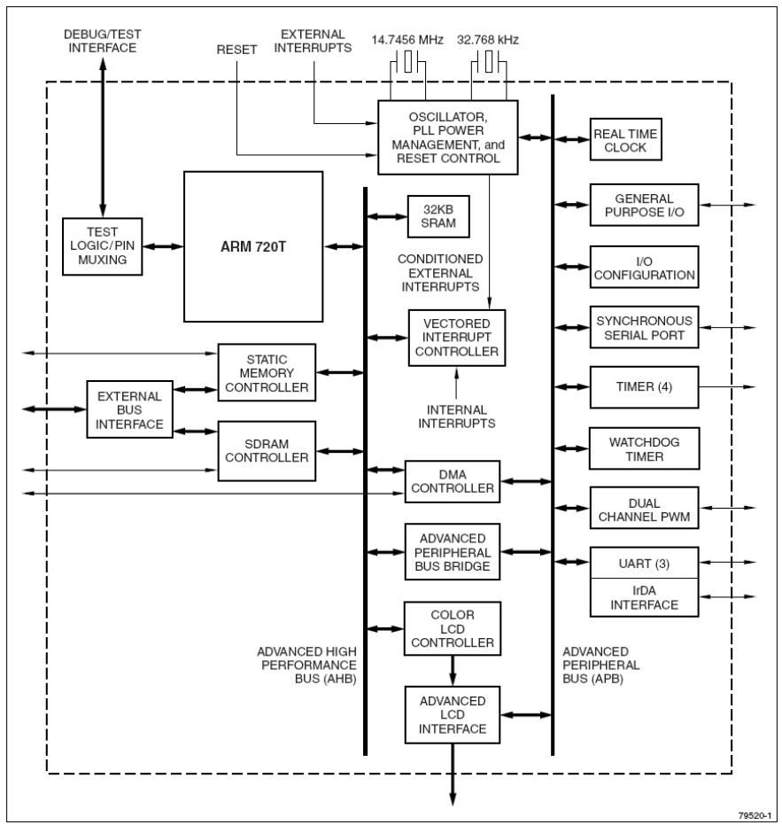

Figure 2.0 LH79520 system block diagram

The core and memory controllers utilize an Advanced High-Performance Bus (AHB) and interface to external memory through an External Bus Interface (EBI). Essential on-chip peripherals are accessed via a 32-bit Advanced Peripheral Bus (APB) connected to the AHB by a 32-bit bridge.

System memory map is shown in Figure 2.1. The SoC offers flexible booting options by remapping any memory technology to its lowest address range. At the same time the memory is mirrored at its original location too. This feature makes it possible to boot from on-chip RAM, the external SDRAM or the external boot ROM.

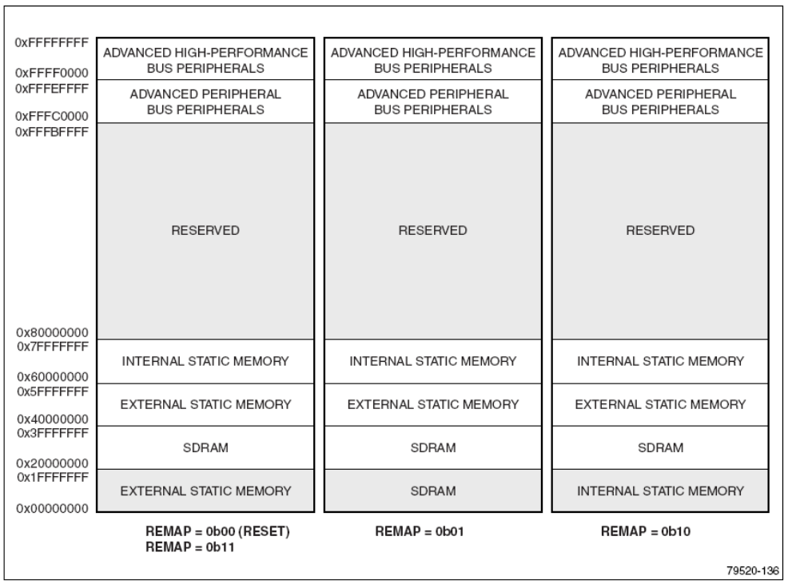

Figure 2.1 System memory map

Flexible clocking option is available, namely, the standard bus clocking mode and the fastbus option. In the standard clocking mode, the core and bus are driven by different clock frequencies FCLK and HCLK. Synchronization is accomplished by introducing wait states. In the fastbus option, both core and bus are inherently synchronized since they are driven by the same source. This however limits the core frequency because bus has a maximum frequency limit of 51MHz and core clock is also locked to that.

Detailed description of all the peripherals is beyond the scope of this text. The LH79520 User’s guide [1] can be referred for further information.

* In the current design, bus is overclocked to 77MHz and Fastbus mode is used.

3.0 Memory Subsystem

3.1 The Boot ROM and Static Memory Controller (SMC)

As in any microprocessor based system, this SBC also contains a non-volatile program memory and data RAM. Generally the non-volatile code memory is a Flash based device which has operating speed limitation whereas the data memory can operate at maximum available bus frequencies. System can be designed by selecting one of the two topologies;

1. The executing program can be first copied to SDRAM and then executed from there.
2. Code can be directly executed from the Flash memory.

Choice has to be made keeping in mind the system application. For example, if the application requires a lot of display and signal processing then most communication will be between the CPU and the data RAM. Therefore it is feasible to connect a half bus width (16-bit) code memory which reduces the complexity, board space and overall cost of the design.

Figure 3.0 shows the full memory space of the processor and the address range that is available for interfacing static memory. The address range is divided into seven banks of variable bus width (at reset) with an internal decoder for chip select signals. On device reset, and remapping external static memory to address range 0x00000000, memory bank controlled by nCS0 is selected. Therefore, it is essential to place the boot ROM at this location. The LH79520 contains an internal 32KB SRAM that operates at core clock frequency and is used as L1 cache.

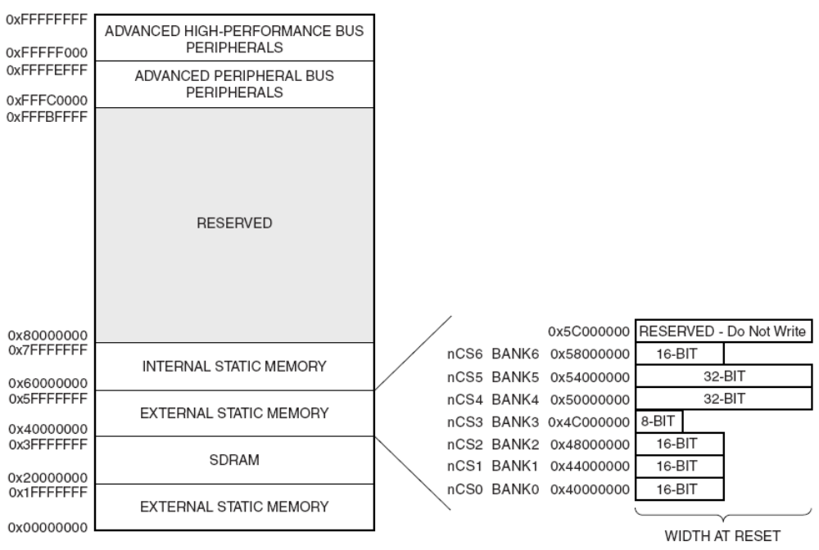

Figure 3.0 LH79520 Memory Map and Static Memory Controller bank division
Figure 3.1 shows the signals available for interfacing any static memory to the processor. nCS6-nCS0 are active low chip select lines. Separate read enable nOE and write enable signals are available along with byte lane control signals nBLE3-nBLE0. For interfacing slow devices, either a fixed wait state can be programmed in the static memory controller’s register or nWAIT can be used for devices having READY signal line.

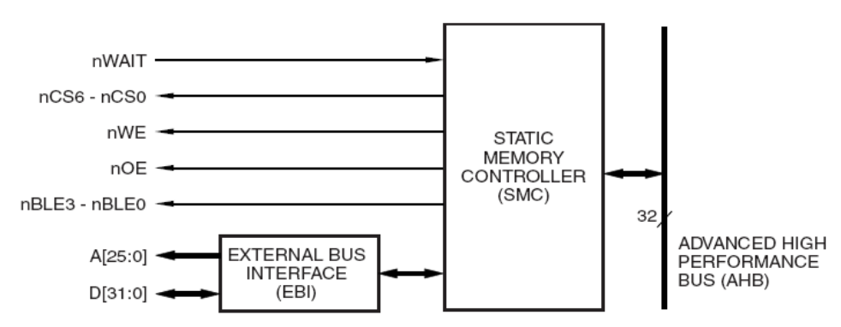

Figure 3.1 Static memory controller external interface lines

For the presented application, a 4MByte, 16-bit wide (70ns) flash device was used. Wait states were introduced in software by programming the SMC register. Since it is a 16-bit wide device, address lines A1 is treated as the LSB of the address bus and connected to the address input LSB of the memory chip.

3.2 System RAM and the Dynamic Memory Controller (SDRC)

As mentioned earlier in the text, the intended application requires reasonable amount of data memory preferably 8MBytes or more. Since system RAM is also shared with the display memory, a higher memory capacity also offers later up-gradation to higher resolution display panels. Constructing large memory banks with multiple SRAM chips ceases to be an option after few hundred Kbytes, therefore dynamic RAMs become an inherent choice. Also, since an on-board SDRAM controller is present on-chip with the 79520’s core, it makes system design simpler and efficient with dynamic memories. For the present application, a 32-bit wide 8Mbyte SDRAM from Micron Technologies [2] was used. The memory devices supports clock speeds till 143MHz and therefore can be interfaced to the processor at full bus frequency.

The SDRC provides all necessary signals to interface the LH79520 to SDRAM devices and includes a Read Buffer and a Merging Write buffer. The SDRC can accommodate two banks of external SDRAM memory, each up to 128M in size controlled by two chip select signals nDSC0 and nDSC1. Address range starting from 0x20000000 was selected to interface the memory device. Figure 3.3 shows the signals available for interfacing the SDRAM. nRAS and nCAS are the row and column refresh signals respectively. SDCLK and SDCKE are the clock and clock enable signals. nSDWE is used as write enable and DQM3-DQM0 are the byte-wide output enable signals.

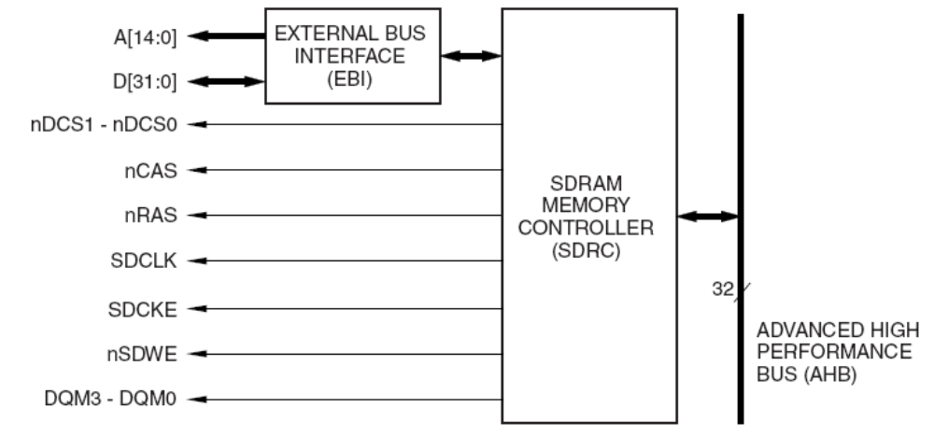

Figure 3.3 SDRAM controller external interface lines

When the SDRC is controlling the external address bus, it uses the bus differently than the SMC because SDRAM devices require multiplexed address signals. Multiplexing is required because SDRAM devices use row/column/bank addressing schemes. The SDRC Chip Select signals (nDCS0:nDCS1) operate according to the addressing scheme like that of a standard static memory, but the actual addresses placed on the external address bus during SDRAM accesses are encoded by the SDRAM Controller for the particular SDRAM memory devices in use. The exact manner in which the addresses are multiplexed depends upon the SDRC Configuration register programming. Detailed description on connecting individual address lines for different class of memory devices can be found in the LH79520 Users Guide [1].

4.0 Display Controller and TFT Panel

The primary reason for selecting LH79520 was its extremely flexible integrated color LCD controller (CLCDC). The CLCDC provides all necessary control and data signals to interface the processor directly to a variety of color and monochrome LCD panels, including STN and TFT panels. The Advanced LCD interface module included with its controller modifies the CLCDC output and allows the processor to connect directly to the Row and Column driver chips on thin panels. The controller supports 16-bit color with display resolution as high as SVGA (1024x768) and screen refresh rates up to 75Hz.
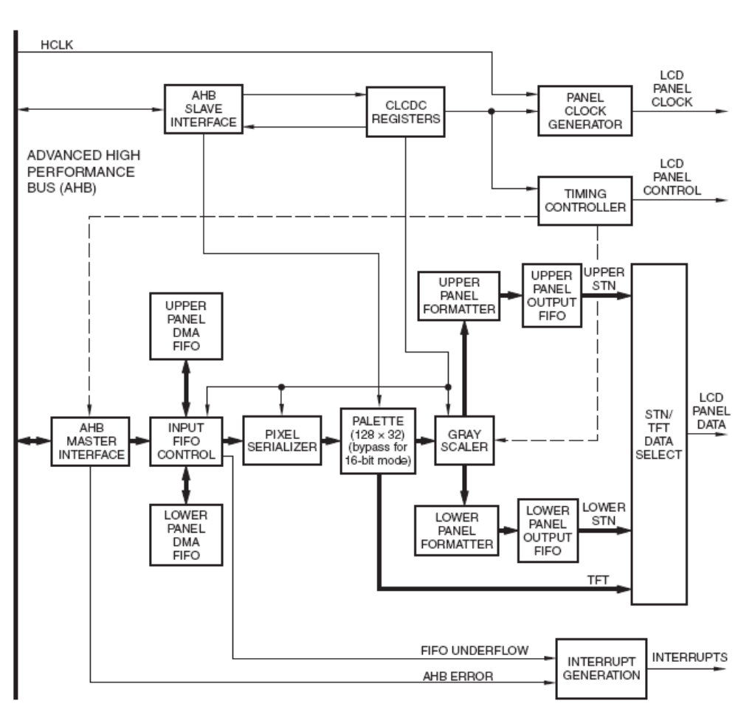

Figure 4.0 Color LCD controller block diagram

Figure shows the block diagram of the integrated LCD controller. The LCD controller retrieves image data from a frame buffer, formats the data for the specific type of LCD panel used, and writes it to the panel. The controller also generates the signals that enable the panel to display the formatted data. Image data is stored in a frame buffer, which can be located in internal or external static memory, or in SDRAM. The controller retrieves raw image data from the frame buffer by its own dedicated two-channel DMA. The controller utilizes two clock signals that may operate asynchronously at different frequencies. DMA operations that access the frame buffer use the AHB (fast) clock. A second, slower clock drives the logic that creates the control signals and presents formatted data to the LCD panel.
The following parameters can be programmed in the CLCDC:

• Horizontal front and back porch width
• Horizontal synchronization pulse width
• Number of pixels per line
• Vertical front and back porch width
• Vertical synchronization pulse width
• Number of horizontal lines per panel
• Number of panel data clocks per line
• Programmable signal polarities, active HIGH or active LOW
• AC panel bias
• Panel data clock frequency (LCDDCLK)
• Bits-per-pixel

The signals that are required for interfacing a color TFT panel are nBit/color (RGB) data lines along with control lines that include horizontal and vertical synchronization pulse and pixel data clock. Signal timings and polarity can be programmed according to the display used. For TFT mode of operation the grayscaler and the formatter are both bypassed. Image data is transferred by DMA operation from the frame buffer to the doubled FIFO. Data from the FIFO is split by the Pixel Serializer into 16-, 8-, 4-, 2-, or 1-bit sections, depending upon the color depth of the panel.

For the current application, a 240x160 pixel 9-bit transflective LCD panel was used [4]. This 2.7” display consumes less than 30mA of current (including LED frontlight) at pixel clock frequency of 25MHz. This form factor along with low power consumption makes it suitable for battery powered hand-held applications.

Figure 4.1 Sony 240x160 9-bit TFT panel block diagram
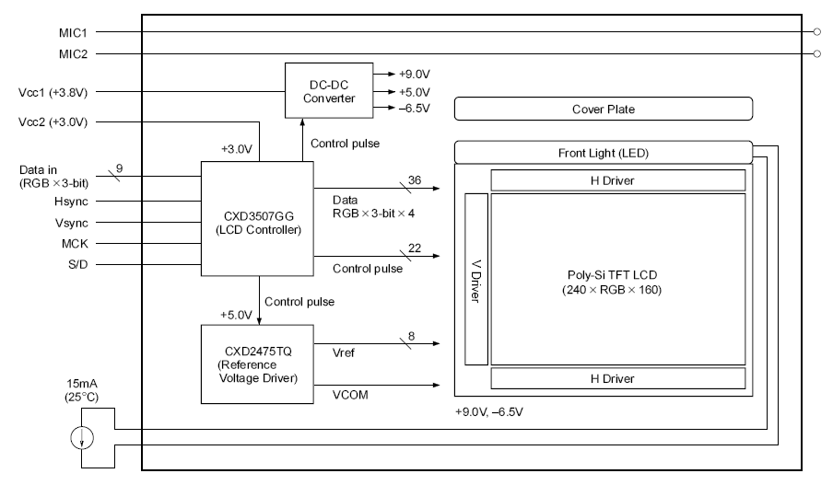
Figure 4.1 shows the block diagram of the panel used. As shown, secondary controller for decoding the input data, the horizontal and vertical drivers along with the LCD bias voltage generator is built into the panel. The 15mA current source is required for maintaining constant illumination for the front light. Since the operating voltage for the SBC is 3.3V, a boost converter is required to drive the front light LEDs. Figure 4.2 presents simple 1MHz inductor based boost converter using TI’s TPS61041 [8] white LED driver IC.

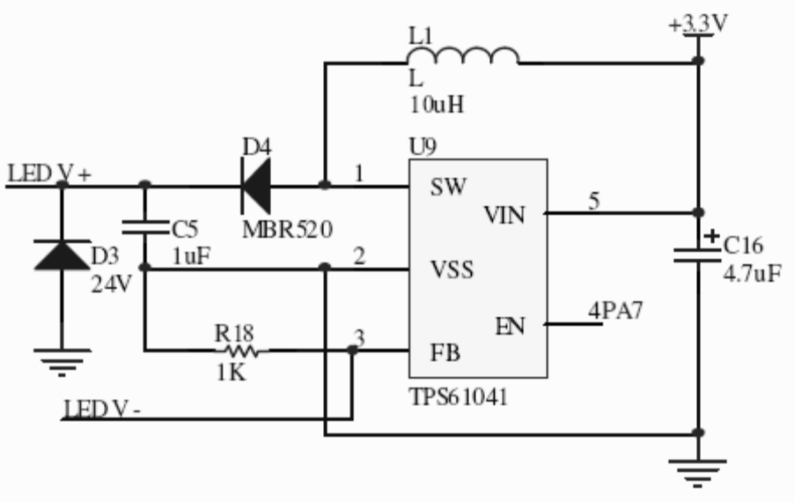

Figure 4.2 Figure 4.2 Voltage booster/constant current white LED driver circuit

5.0 Design Issues

As with any high speed board layout, lots of constraints are placed on design with respect to signal integrity. The clock has to be distributed throughout the circuit without any skews. Clean power planes and ample supply bypassing are an absolute essential for reliable operation. All these issues are further complicated when number of signal layers available at hand for routing are limited. As mentioned in earlier sections, the board was designed with only two routing layers. Simple tricks were applied to ensure glitch free operation.

For instance, the data bus between the processor and main memory was kept as short as possible. Lengths of latching signals lines like nWE, nOE were deliberately increased to ensure that the data bus had settled down before the enabling signal arrived. For clock signals, low value resistors were placed in series that acted like inductors at high frequencies to take care of excessive ringing due to pad capacitances.

Another big concern is routing the supply to all the components and decoupling it. The LH79520 comes in a 176pin TQFP package with 0.40mm pitch. Core and I/O power lines are distributed throughout the chip at equal intervals.

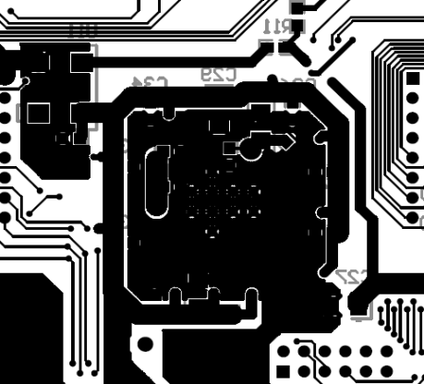
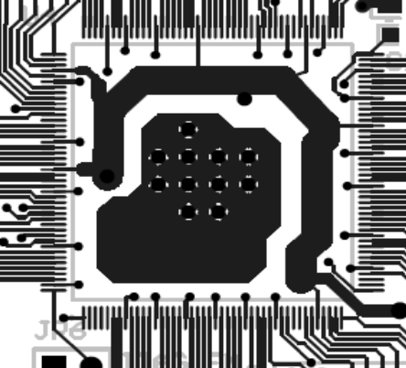

Figure 6.0 Bottom and Top layer track layout beneath the processor

As seen in figure 6.0, a common low inductance ground plane was placed below the chip with a wide I/O supply (3.3V) track encircling it. This allowed for easy placement of bypass capacitors distributed throughout the chip periphery. Vias were introduced to carry the power to the top layer and to the pins with minimal lengths of narrow tracks. Similarly, the 1.8V core supply was routed by encircling a wide track on the inside of the processor pin periphery. Bypass capacitors were place on the bottom. Same approach was followed for routing power to the SDRAM chip. All power tracks were taken from a single point from the regulator to avoid voltage dropouts.

Appendix A : Schematic Diagram

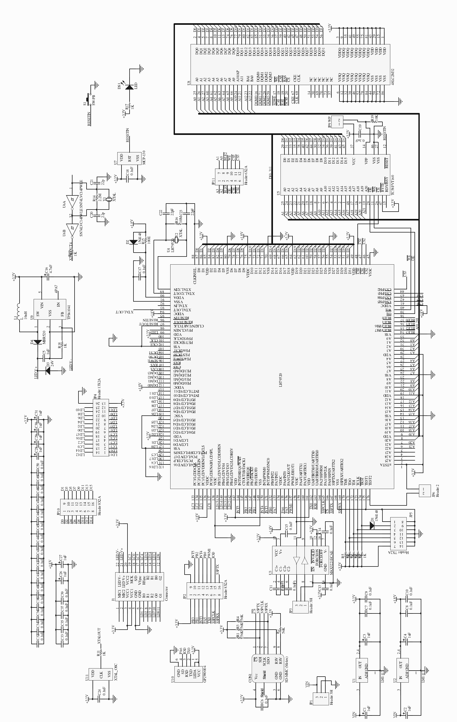

Appendix B: Top and Bottom Layer PCB Track Layout

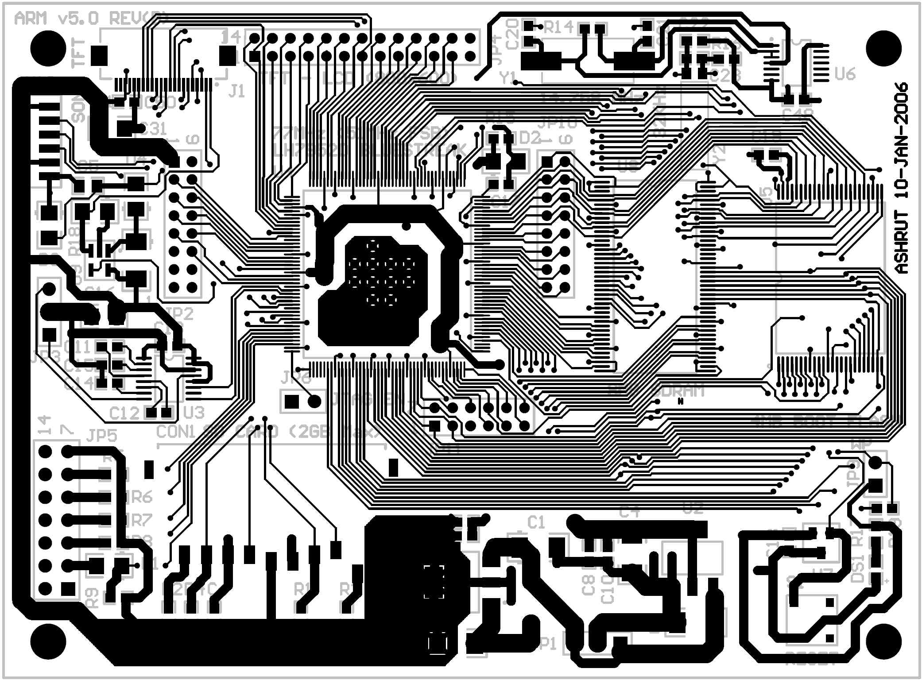

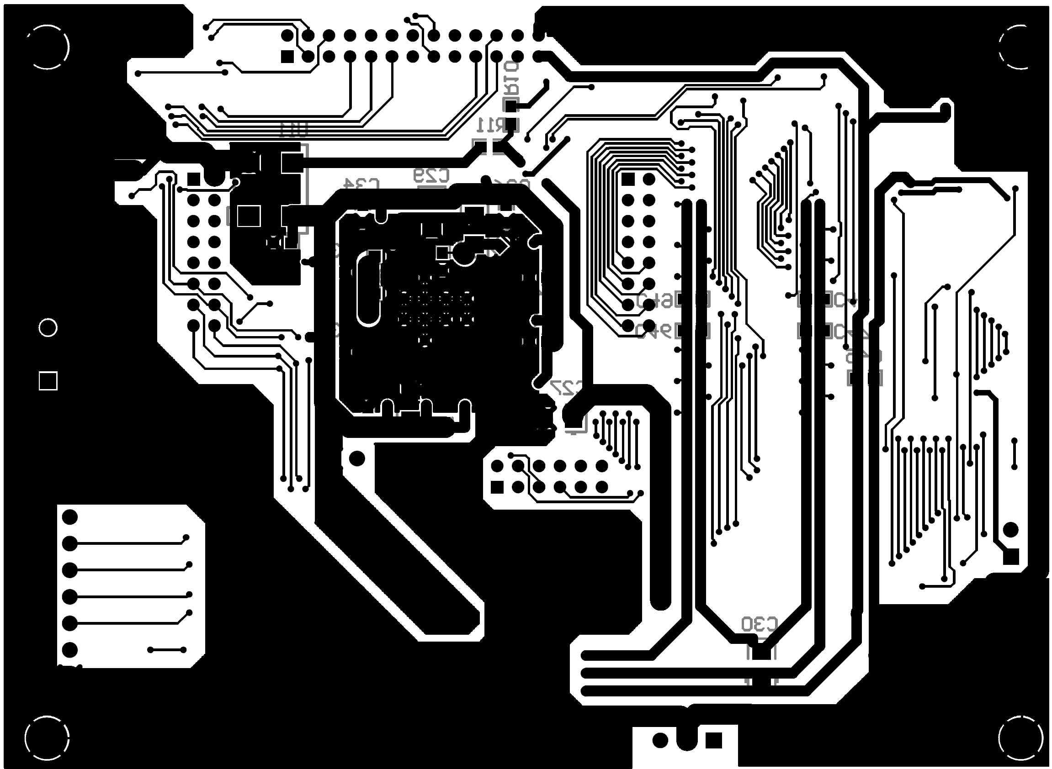

References

[1] LH75920, “Sharp LH79520 Bluestreak Priliminary User’s Guide,” Datasheet 2003.

[2] MT48LC2M32B2, “512K x 32 x 4 banks SDRAM,” Datasheet 2002

[3] LHF00L15, “32Mbit 70-ns Flash Memory,” Datasheet 2003

[4] Sony ACX705AXM “2.7in. 240x(3)x160 color TFT Panel,” Datasheet

[5] ARM [Online]. Available: http://www.arm.com/.

[6] Sharp Microelectronics [Online]. Available: http://www.sharpsma.com/.

[7] Micron Technologies [Online]. Available: http://www.micron.com/.

[8] Texas Instruments. [Online]. Available: http://www.ti.com/.

